West Point Balloon Sat Wi-Fi Analysis White Paper

CDT Bull, Tyler A.

CDT Westerhaus, Joshua J.

Sponsor - LTC Hamilton, Steven

Table of Contents

**3**

Abstract

**4**

A Brief Introduction to West Point Balloon Sat

**5**

Data Gathered During the Flight

**6**

General Flight Statistics

**7**

BSSID Manufacturer Information

**8**

BSSID Geolocation

**9**

Conclusion

**10**

References

Abstract

Balloon satellite projects have been launched since the 1960’s with varying degrees of success. West Point Astronomy Club has launched a Balloon Sat annually since 2011 with varying degrees of success. The Balloon Sat launched in 2019 included a directional receiver pointed towards the earth to receive Wi-Fi signals. By analyzing the data received by the Balloon Sat there are many statistics that prove interesting about Wi-Fi networks.

These statistics are meaningful because we can visually represent the data through graphs and charts. The data shows that the higher the balloon goes, the less signals that it receives. The lower MHz is picked up higher due to the properties of radio waves. The higher MHz does not go as far but is used more commonly in higher populated areas.

A Brief Introduction to West Point Balloon Sat

West Point Astronomy Club launched the first balloon satellite in 2011. Every year since, another balloon is launched with different sensors. The balloon records minimally the latitude, longitude and altitude of the balloon. Radiation and temperature recording devices have also been included with varying degrees of success.

The balloon is launched with three parts. First is the payload at the bottom. Next is the recovery parachute in the middle and the balloon itself at the top.

West Point Astronomy Club Balloon Sat Launch, 14 April 2012

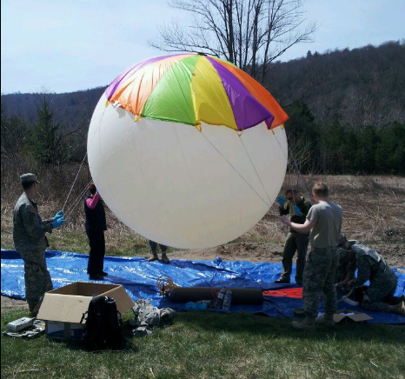

The life cycle follows three distinct stages during the flight. The initial release follows a steady increase in altitude. During this phase the balloon will expand as it goes higher in altitude. This is due to the decreasing pressure of the surrounding atmosphere. Eventually, the balloon hits a point where the size of the balloon exceeds the limitations of the rubber, it pops going to the second stage.

The second stage is brief but hectic. After the balloon pops, it goes into a free fall where the parachute has not engaged due to several factors. One being a lack of atmosphere to catch the parachute. The other is that the strings tend to get tangled up in the parachute and take a minute to get untangled.

The last stage is a gentle decent with the parachute engaged. This stage lasts until the payload hits the ground, or recently, a tree to get tangled in. Rescue attempts to retrieve the payload include professional climbers and helicopter rescue.

The flight path of the balloon follows a typical pattern. It follows a due east heading until the balloon gets above around 20,000 meters. From there it hits the jet stream and moves in a north/westerly direction. When the balloon pops and descends under the jet stream, it moves back in an easterly direction until it lands.

Balloon Sat Path, April 6, 2019

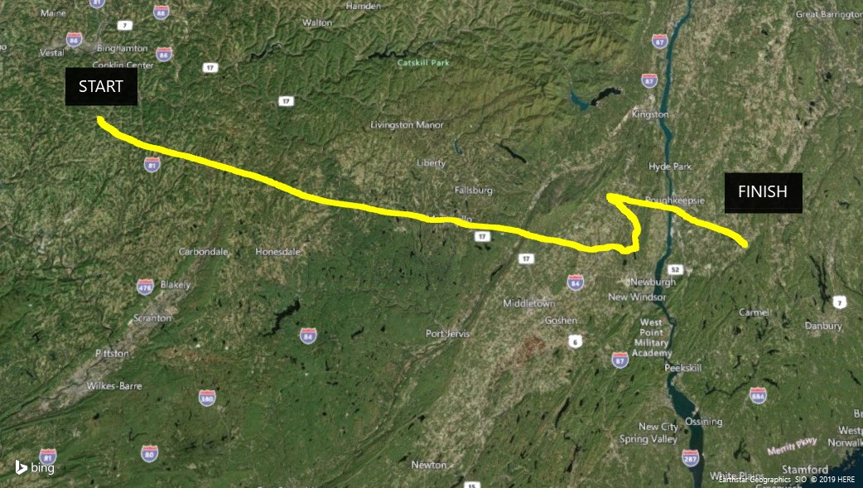

Data Gathered During the Flight

The data gathered during the flight was BSSID, ESSID, power, channel, encoding type, mode, pic filename, latitude, longitude, altitude, temperature and created at time (see example below). Every 16- or 17-seconds a sensor reading is taken. All the hardware is hooked up to a Raspberry Pi running a Python script that records the data. Graph below shows the altitude versus the number of BSSID’s received.

Balloon Sat Payload, April 6, 2019

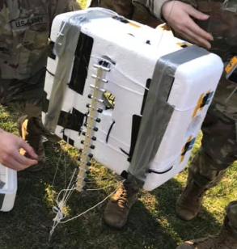

Payload is put together by the West Point Astronomy Club in conjunction with the West Point HAM Club. Wi-Fi data is gathered using a 2.4 GHz Yagi directional antenna (see picture right).

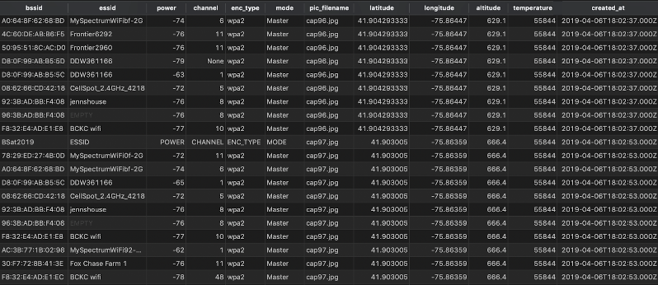

Sample Data from Balloon Sat Database File

General Flight Statistics

The flight lasted three hours, nineteen minutes and thirty-eight seconds. The balloon reached a maximum altitude of 31,561.8 meters above sea level. The balloon was launched at Montrose, PA at 1800 and landed at Poughquag, NY at 2119. The balloon traveled a total of 146.44 miles reaching speeds of 131.64 miles per hour, taking altitude and distance into account (see picture below). The average speed of the balloon was 33.45 miles per hour. During that time period the balloon sat logged 3783 entries. When the balloon popped at the maximum elevation, it fell 5,614.9 meters in one minute, 36 seconds before the parachute engaged.

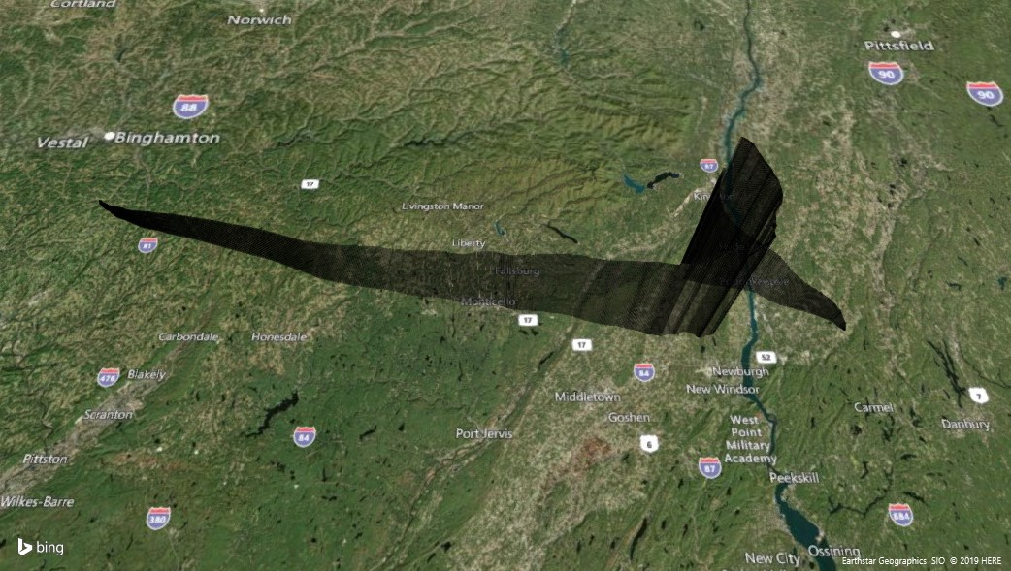

Balloon Sat Path and Elevation, April 6, 2019

BSSID Manufacturer Information

|  |  |  |
| --- | --- | --- |
| UNIQUE BSSID MANUFACTURER | COUNT | PERCENT |
| SenaoNet SENAO Networks, Inc. | 423 | 45.05% |
| Technico Technicolor CH USA Inc. | 111 | 11.82% |
| Pegatron Pegatron Corporation | 67 | 7.14% |
| Netgear | 66 | 7.03% |
| ArrisGro ARRIS Group, Inc. | 63 | 6.71% |
| Sagemcom Sagemcom Broadband SAS | 36 | 3.83% |
| AsustekC ASUSTek COMPUTER INC. | 33 | 3.51% |
| Tp-LinkT Tp-Link Technologies Co.,Ltd. | 24 | 2.56% |
| HonHaiPr Hon Hai Precision Ind. Co.,Ltd. | 20 | 2.13% |
| Ubiquiti Ubiquiti Networks Inc. | 20 | 2.13% |
| BelkinIn Belkin International Inc. | 19 | 2.02% |
| Google Google, Inc. | 12 | 1.28% |
| HughesNe Hughes Network Systems | 12 | 1.28% |
| Cisco-Li Cisco-Linksys, LLC | 8 | 0.85% |
| Eero eero inc. | 5 | 0.53% |
| CompexPt Compex Systems Pte Ltd | 4 | 0.43% |
| Cisco Cisco Systems, Inc | 2 | 0.21% |
| HewlettP Hewlett Packard | 2 | 0.21% |
| Trendnet TRENDnet, Inc. | 2 | 0.21% |
| Actionte Actiontec Electronics, Inc | 1 | 0.11% |
| AlconTel Alcon Telecommunications Co., Ltd. | 1 | 0.11% |
| AskeyCom Askey Computer Corp | 1 | 0.11% |
| D-LinkIn D-Link International | 1 | 0.11% |
| ExtremeN Extreme Networks, Inc. | 1 | 0.11% |
| Humax HUMAX Co., Ltd. | 1 | 0.11% |
| Microwav Microwave Data Systems Inc. | 1 | 0.11% |
| MitsumiE Mitsumi Electric Co.,Ltd. | 1 | 0.11% |
| StorageC Storage Computer Corporation | 1 | 0.11% |
| Yestechn YESTECHNOLOGY Co.,Ltd. | 1 | 0.11% |
| TOTAL | **939** |  |

BSSID information, or the MAC address as it is commonly known, was collected at every opportunity. The BSSID’s were received in the format of MM:MM:MM:SS:SS:SS, where the first half is manufacturer information(M) and the second half is the identification information for each device(S).

The maximum altitude that the payload received a signal was 10,013.5 meters above sea level. 939 unique BSSID’s were received during the flight of the balloon. Each of the BSSID’s correlated to one of 29 different manufacturers. The chart to the right shows how many times each manufacturer’s device is picked up during the flight. Senao Networks Inc. is picked up the most. Senao is a technology company from Taiwan. The interesting part is that Senao has a product line that specializes on outdoor wireless devices. This would make sense that their devices are the most commonly picked up during the flight.

During the flight the average time the balloon sat picked up a signal was 59 seconds. The longest a signal was in contact with the balloon was ten minutes, thirty-three seconds. There was no geographical concentration of any specific manufacturer.

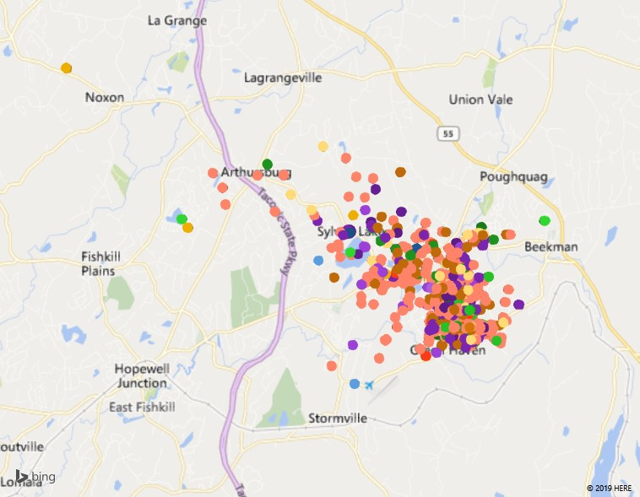

Geolocated BSSID’s Sorted by Manufacturer (Landing)

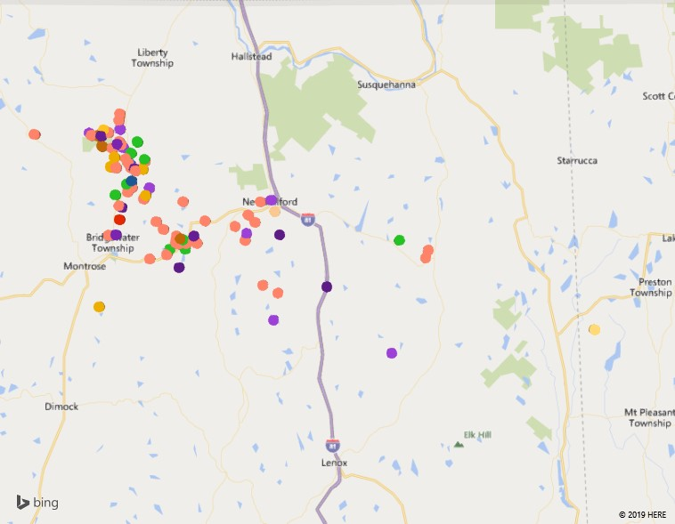

Geolocated BSSID’s Sorted by Manufacturer (Take-off)

BSSID Geolocation

Geolocating the signals using the BSSID was accomplished through Google’s Geolocation API. The service requires two BSSID’s formatted as JSON and submitted through POST. The API will return a latitude, longitude and accuracy based on the two BSSID locations. Using this method, 939 unique BSSID’s were submitted with 730 successful results returned. This is a success rate of 77.74%. The most accurate the results returned was 150 meters while the least accurate was 1,498 meters. The average accuracy was 531.21 meters. A heat map was produced of the takeoff and landing areas (below) that shows a visual representation of the locations that a signal was received by the balloon sat.

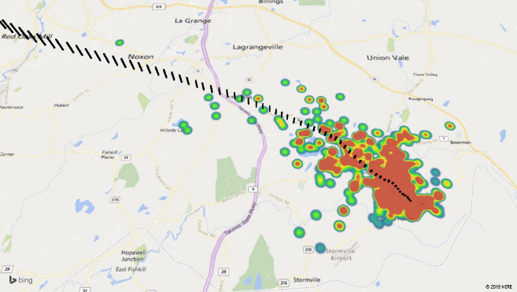

Balloon Sat Landing (black) with Geolocated BSSID’s (heat map).

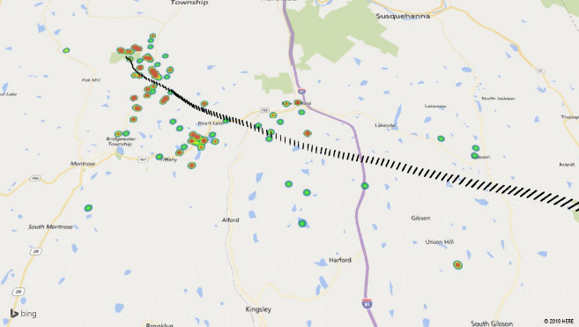

Balloon Sat Take-Off (black) with Geolocated BSSID’s (heat map).

The largest distance that was found between the balloon and the geolocated BSSID was 5,381.82 miles. The average distance found between the points is 4.15 miles. We also analyzed the number of times a BSSID was detected between elevations. We grouped the altitudes every 100 meters using a floor function. This creates an interesting graph which shows which altitudes that the balloon sat picked up more signals.

Conclusion

Showing the data collected in a visual manner allows an easier understanding of what it means. Looking at the graph of BSSID signals picked up versus altitude we can see that once the balloon sat ascended past 10,000 meters, it did not receive any Wi-Fi signals until the balloon descended. This represents a big gap where the receiver is ineffective. Interpreting and extrapolating data like this can help and guide future experiments.

Looking at the graph showing the correlation between number of BSSID signals picked up per altitude, there is a clear spike between 3,000 and 3,500 meters. If a balloon’s altitude can be regulated to remain in that zone, the number of BSSID’s picked up would increase dramatically. If the intent was to do war flying, keeping the altitude lower would be extremely effective. There could also be several balloons launched simultaneously but a set distance apart to get a wider pool of Wi-Fi BSSID’s.

A factor for results could also be population densities. When the balloon was launched, the area was a lower population area in rural Pennsylvania. The payload landing near Green Haven, New York had a significant impact on the amount of data received. If the balloon can be kept at a consistent altitude, the frequency of Wi-Fi signals would show where the population densities are higher and lower.

References

*Google*, Google, developers.google.com/maps/documentation/geolocation/intro.

Mitchell, Bradley. “What's MAC Address and How Does It Work?” *Lifewire*, Lifewire, 18 July 2019, www.lifewire.com/introduction-to-mac-addresses-817937.

*Senao Networks, Inc. 神準科技股份有公司*, www.senao.com/English/default.aspx?TYPE=test.htm&PT=DespageN&tv_TCAT_POS=0&PID=a1&CATNO0=A&IDX=3.0&CNT=1&CATNO1=A1.

“West Point Balloon Sat.” *Facebook*, www.facebook.com/West-Point-Balloon-Sat-204803066214455/.

*Wireshark · OUI Lookup Tool*, www.wireshark.org/tools/oui-lookup.html.